A0 AND Gate
Architecture specification — for review and approval
Document | Complete definition of a two-input AND riboregulator: domains, lengths, design rules, and the calculations that will rank candidates.
Status | Draft for supervisor review. Section 9 lists twelve open decisions.
Prerequisites | None. The document is self-contained.
Date | 1 September 2026

What is being asked
Everything in sections 1–8 is fixed and ready to implement. Section 9 lists twelve decisions we need from you before code is written and constructs are ordered. Each carries our recommendation and the reason it matters. Six are ready to sign off as recommended; six are genuine choices where we do not think the evidence settles it.

1. What we are building
A single mRNA that produces GFP only when two different RNA inputs are present at the same time. One input is a window of gene A, the other a window of gene B. Neither input alone should produce GFP.
The construct is a toehold switch carrying a second, inhibitory hairpin immediately upstream of it. The main hairpin sequesters the ribosome binding site and the start codon. The inhibitory hairpin sequesters the site where the main trigger would otherwise land.
- Trigger B binds a free single-stranded toehold and opens the inhibitory hairpin. This exposes the landing site — and nothing else.
- Trigger A then binds that newly exposed site and opens the main hairpin, releasing the start codon.
The name A0 refers to the one parameter that defines this variant: the unpaired spacing between the two hairpins, conventionally called a, is set to zero. Section 2 explains why that specific number.
2. The two architectures this is built on
The geometry below was measured, not quoted: each published construct was rebuilt from its supplementary sequences and folded with ViennaRNA 2.7.2 at 37 °C. This matters because the published text does not state the stem lengths directly, and they are the numbers we need.
2.1 Measured geometry
 | Green — Series A  (tsgen2 / VISTA) | Kim — main  hairpin (G3n*) | Kim — inhibitory  hairpin (G5)
stem below the internal loop | 9 bp | 11 bp | 11 bp
internal loop | 3 × 3 | 1 × 1 | 1 × 1
stem above the internal loop | 6 bp | 6 bp | 8 bp
total stem | 15 bp | 17 bp | 19 bp
hairpin loop | 11 nt (carries RBS) | 15 nt (carries RBS) | 15 nt (no RBS)
trigger length | 36 nt | 30 nt | 30 nt
free single-stranded toehold | 30 nt | 15 nt | 13 nt
invasion into the stem | 6 bp | 15 bp | 17 bp

Table 1 — the three published hairpins. The highlighted row is the one this specification adopts (§4.1).
2.2 Kim's key result, and why a = 0
Kim held trigger A at 30 nt and slid its binding site upstream, trading two quantities against each other: a, the unpaired spacing between the two hairpins, and *, the number of nucleotides of trigger A's site that lie buried inside the inhibitory hairpin's stem. In their constructs a + * = 15. Three variants were tested:
construct | a | * | behaviour reported
Sw-G5-G3n5 | 10 | 5 | trigger B only modulates the output range — effectively still a one-input switch
Sw-G5-G3n8 | 7 | 8 | intermediate
Sw-G5-G3n11 | 4 | 11 | "a primary input molecule of the two-input AND gate"

The trend is monotonic and it is the entire rationale for A0: the smaller a is, the more the construct behaves as a genuine AND gate. A0 takes a to its limit. With a = 0, trigger A has no exposed nucleotide anywhere on the switch until trigger B has acted — the dependency becomes structural rather than a matter of degree.
The one caveat on this
a = 0 is one step beyond Kim's shortest tested spacing. The direction is supported by their data; the specific value is an extrapolation. §5.3 therefore includes an a = 4 construct as a benchmark, so the panel contains a point that is known to work.

3. The A0 architecture
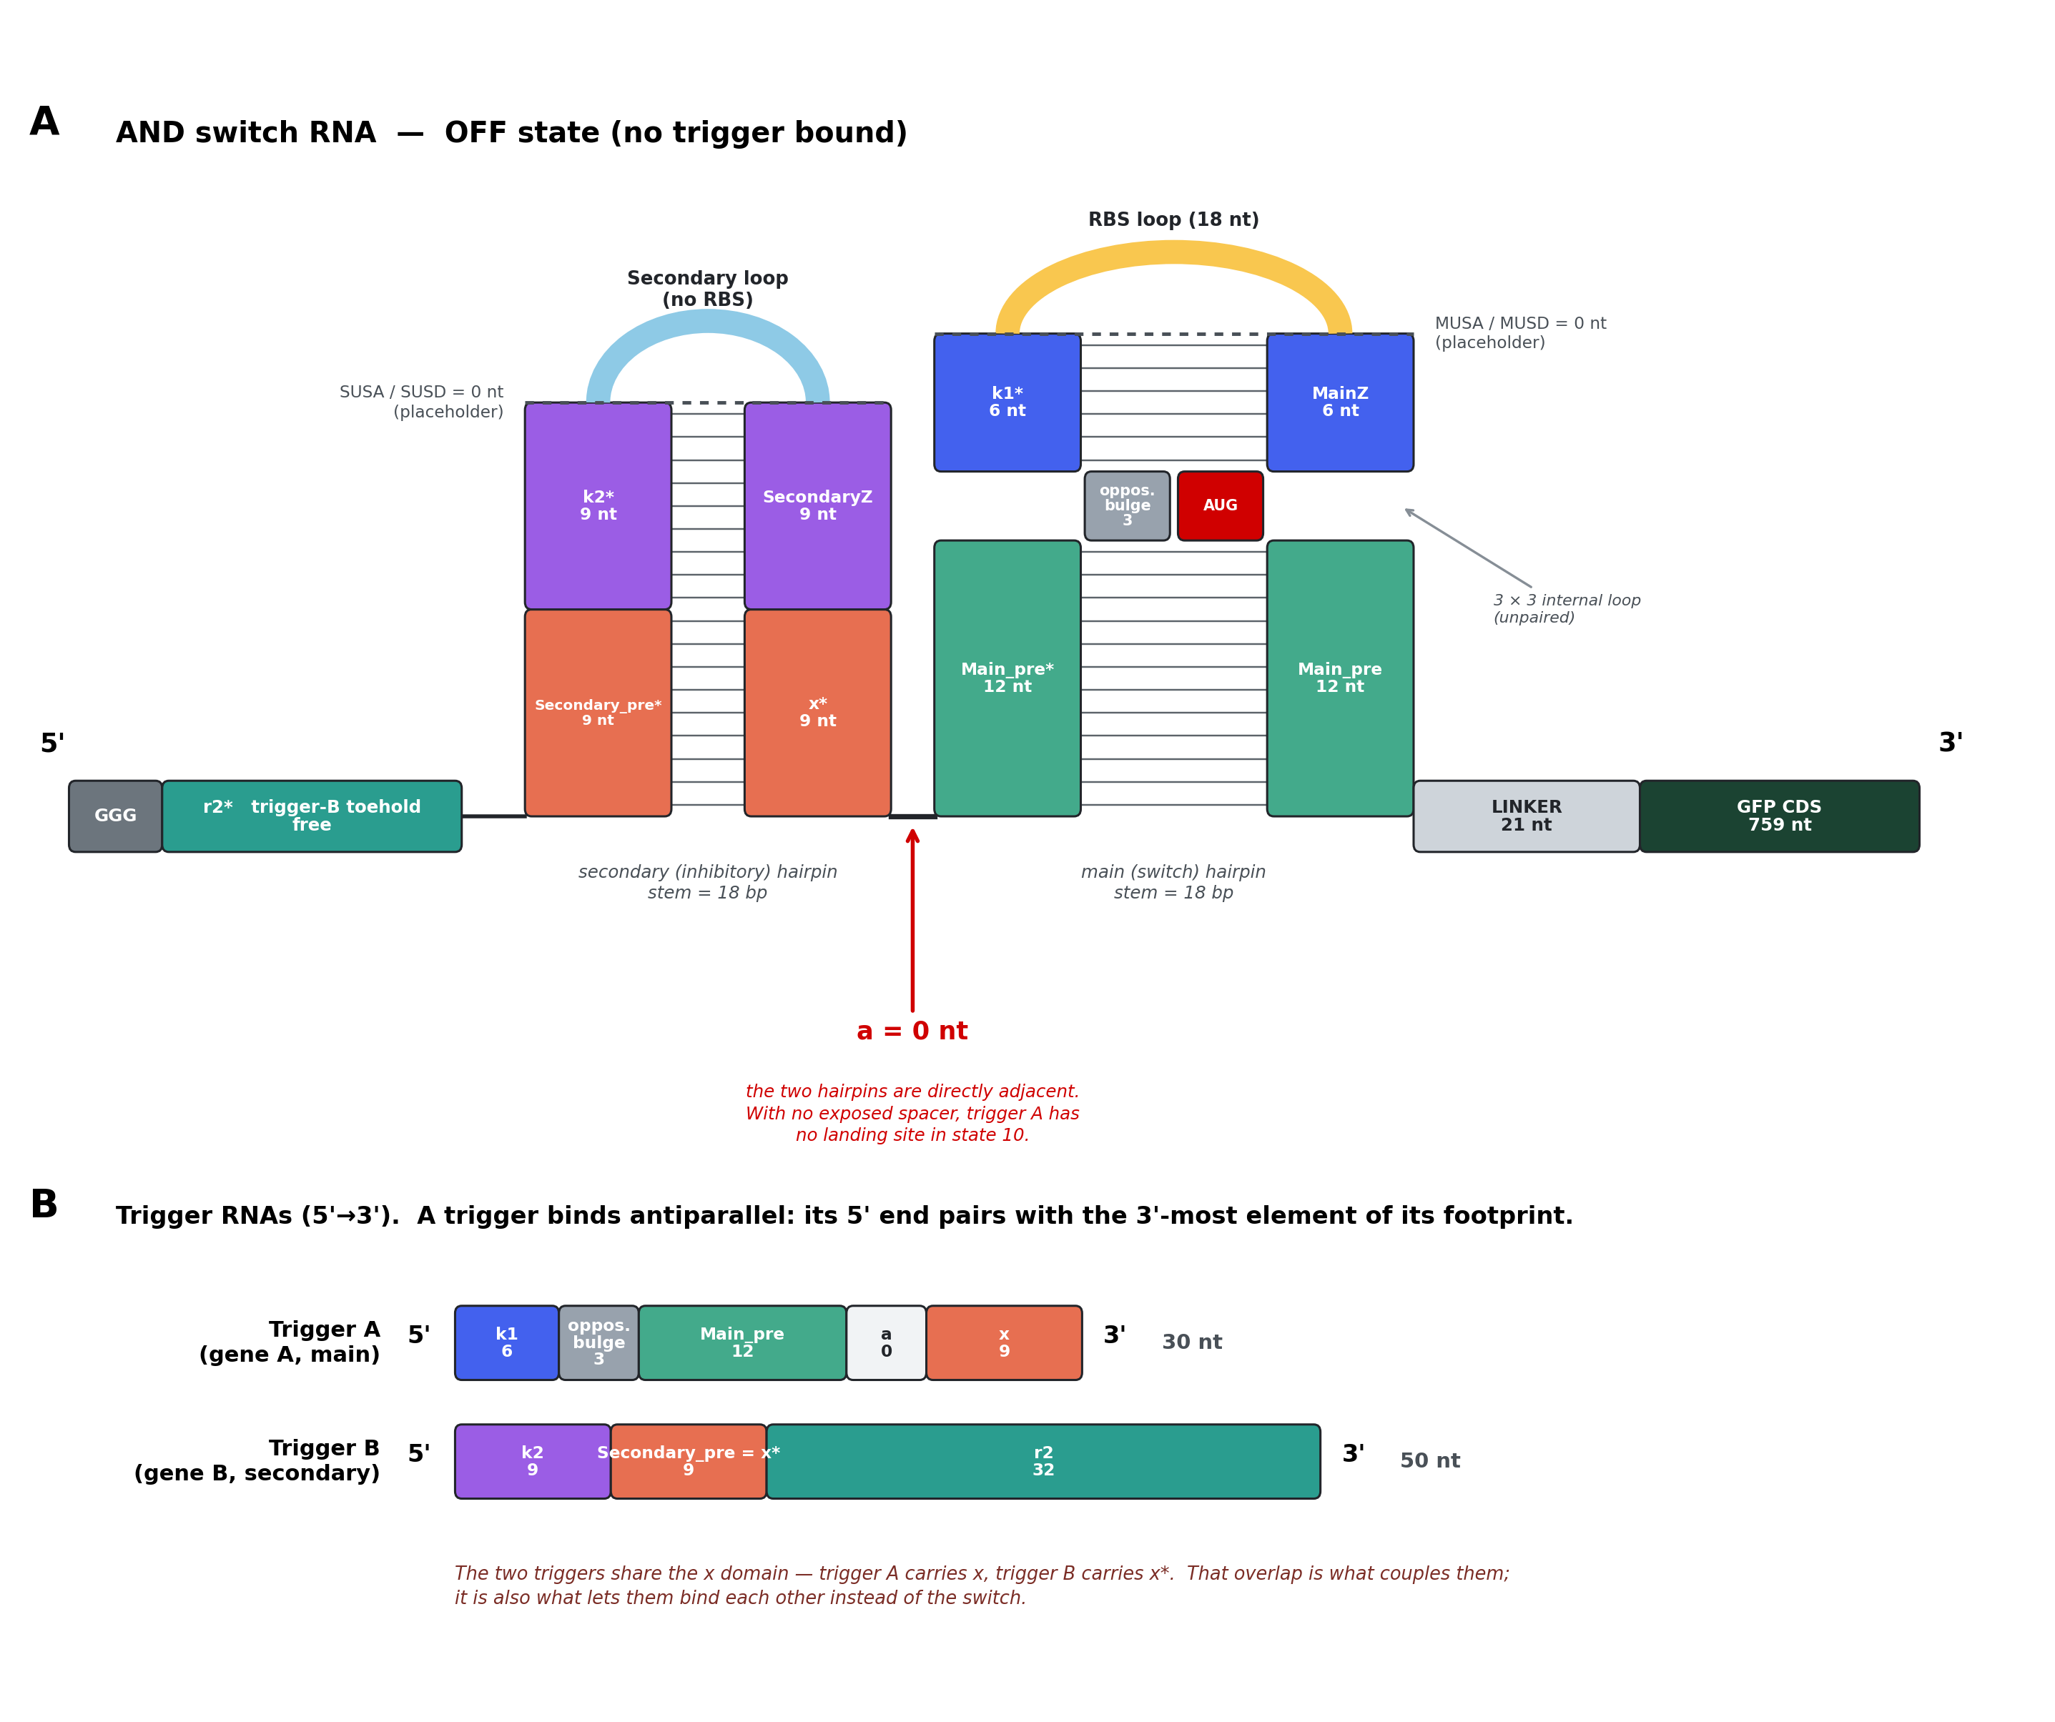
Figure 1. The A0 switch and its two triggers. Domains that pair with each other share a colour. Lengths shown are the reference design: both stems 18 bp, the main stem split 12 + 6 (D2), and |x| = 9. §4 gives the general rule.
3.1 The switch, 5' → 3'
Every element of the construct, in order. "Pairs with" describes the OFF state.
# | element | pairs with | length (nt) | sequence determined by
1 | cap | — free | 3 | fixed: GGG
2 | r2* | — free (trigger-B toehold) | len_r2 | revcomp(r2); window of gene B
3 | Secondary_pre* | x* (#9) | len_x | = x; window of gene A
4 | k2* | SecondaryZ (#8) | 18 − len_x | revcomp(k2); window of gene B
5 | SUSA | SUSD (#7) | 0 | free design — placeholder
6 | Secondary loop | — free | 15 | fixed; must contain no RBS-like motif
7 | SUSD | SUSA (#5) | 0 | revcomp(SUSA) — placeholder
8 | SecondaryZ | k2* (#4) | 18 − len_x | ≈ k2, deliberately weakened (§6.3)
9 | x* | Secondary_pre* (#3) | len_x | revcomp(x); window of gene A
10 | a | — free | 0 | spacer — placeholder, fixed at 0 in A0
11 | Main_pre* | Main_pre (#19) | len_main_pre = 12 | revcomp(Main_pre); gene A
12 | opposing_bulge | — free in OFF;  paired by trigger A in ON | 3 | revcomp of trigger A's 3 nt (§6.4)
13 | k1* | MainZ (#17) | len_k1 = 18 − 12 = 6 | revcomp(k1); window of gene A
14 | MUSA | MUSD (#16) | 0 | free design — placeholder
15 | RBS loop | — free | 18 | fixed
16 | MUSD | MUSA (#14) | 0 | revcomp(MUSA) — placeholder
17 | MainZ | k1* (#13) | len_k1 = 6 | ≈ k1, deliberately weakened (§6.3)
18 | AUG | — free | 3 | fixed: start codon
19 | Main_pre | Main_pre* (#11) | len_main_pre = 12 | window of gene A
20 | LINKER | — free | 21 | fixed
21 | GFP CDS | — free | 759 | fixed

Table 2 — the 21 elements of the switch. The main hairpin is shown at its recommended split, len_main_pre = 12 and len_k1 = 6 (§6.6, decision D2, still open). Only len_x and len_r2 remain free. Elements 5, 7, 10, 14 and 16 have length 0: they are placeholders, kept in the layout so that a future version can add an upper stem to either hairpin, or re-open the inter-hairpin spacer, without renumbering anything.
3.2 The triggers
Trigger A (main, gene A) 5'- k1 - opposing_bulge - Main_pre - a - x -3'
Trigger B (secondary, gene B) 5'- k2 - Secondary_pre - r2 -3'
Reading rule. A trigger binds antiparallel, so its 5' end pairs with the 3'-most element of its footprint on the switch. Listing a trigger's domains in switch order gives the reverse of the correct sequence. This rule is why trigger A begins with k1 even though k1* sits deep inside the main hairpin.
The shared domain. Secondary_pre = x*. Trigger A carries x; trigger B carries x*. The two triggers are therefore complementary to each other over len_x nucleotides. That overlap is what couples the two halves of the gate, and it is also the single largest risk in the design (§5.1).
3.3 Mechanism
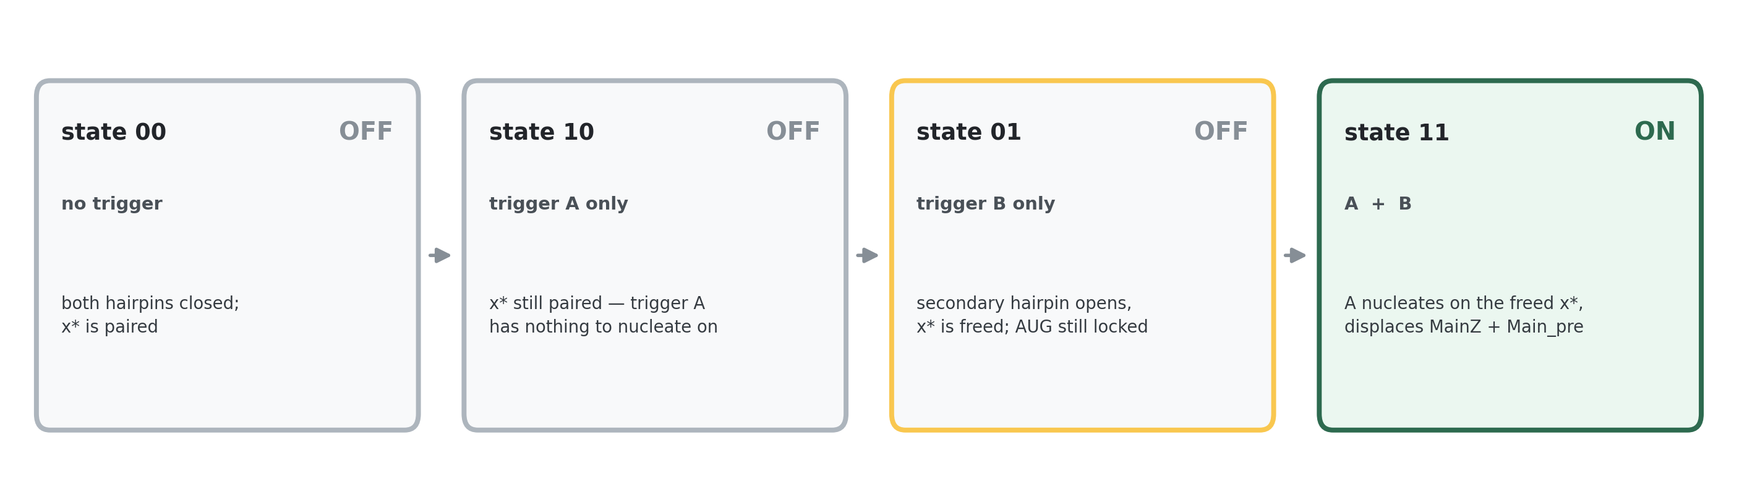
Figure 2. The four input states. Only 11 produces GFP.
In state 11 trigger A's entire nucleation budget is len_x nucleotides — that is all trigger B exposes. Once nucleated, trigger A branch-migrates through Main_pre* and k1*, displacing Main_pre and MainZ and freeing the start codon.
4. Lengths
4.1 Decision: both stems are 18 bp
Both hairpin stems are fixed at 18 bp. Table 1 shows the published values are 15, 17 and 19 bp; 18 sits inside that band and close to the mean. There is no published value of exactly 18 to copy, so this is a choice rather than a reproduction — but it is a choice inside the tested range, which is the point.
4.2 What 18 bp determines
Fixing the stem closes every remaining length in the design. Each stem is split in two by an unpaired region, and the two halves must sum to 18:
main hairpin len_main_pre + len_k1 = 18
secondary hairpin len_x + len_k2 = 18
So len_k1 and len_k2 are not free parameters at all — they are consequences:
quantity | rule | worked values
len_k1 | 18 − len_main_pre | len_main_pre = 12 → len_k1 = 6 (§6.6)
len_k2 | 18 − len_x | |x| = 4 → 14 |x| = 9 → 9 |x| = 14 → 4
length of trigger A | 18 + 3 + len_x = 21 + len_x | |x| = 4 → 25 nt |x| = 9 → 30 nt |x| = 14 → 35 nt
length of trigger B | 18 + len_r2 | len_r2 = 32 → 50 nt
len_main_pre | multiple of 3 (§6.1) | 12 (see §6.6 for why not 9)

Two of these are worth pausing on. Trigger A's length is 21 + len_x regardless of how the main stem is split — the split moves nucleotides between k1 and Main_pre without changing the total. And at |x| = 9 trigger A is exactly 30 nt, the length both Green and Kim used.
len_k1 is not free either. §6.6 shows that k1 is exactly the distance between the Shine–Dalgarno sequence and the start codon, which is a determinant of translation initiation rate. Green, Kim and all five of our own tested switches put that distance at 6 nt. Setting len_k1 = 6 forces len_main_pre = 12, and every length in the construct is then closed.
4.3 Trigger B — the split is now determined
An earlier draft flagged "the split of trigger B's ~50 nt" as undefined. The 18 bp decision closes it, and the reason it was ever open is worth stating so the same gap is not re-introduced.
Trigger B is k2 + Secondary_pre + r2. Two of those three are already pinned: Secondary_pre = x* has length len_x, and k2 has length 18 − len_x. Their sum is 18 whatever len_x turns out to be. So:
len_r2 = (length of trigger B) − 18
At the target length of 50 nt, len_r2 = 32. Before the stem was fixed, both k2 and r2 floated, and a 50-nt trigger could have been split in many ways with very different behaviour — that was the actual gap, not a missing number.
One number here does deserve a second look
len_r2 = 32 nt is trigger B's free toehold. Kim used 13 nt for the same role; Green used 30 nt for a toehold that had no hairpin above it. A 32-nt toehold is long, which buys specificity but also makes trigger B's binding much stronger than trigger A's. This is decision D3.

5. The overlap, and what goes to the lab
5.1 The overlap x is the central parameter
len_x is simultaneously two things, pulling in opposite directions:
- It is trigger A's only nucleation site in state 11 — so longer is better.
- It is the region over which the two triggers are complementary to each other — so longer is worse, because they bind each other instead of the switch.
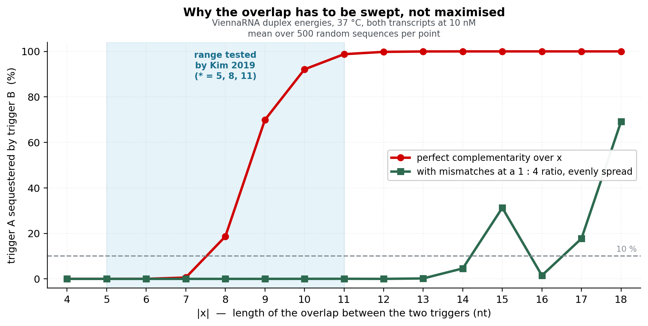
Figure 3. Fraction of trigger A tied up in a trigger-A : trigger-B duplex, against overlap length. Red: perfect complementarity. Green: with mismatches at a 1:4 ratio, spread evenly. The green curve does not stay flat — it climbs again past |x| = 14 and is jagged, because a fixed ratio does not hold the longest complementary run down as the overlap grows. The run, not the ratio, is what the rule constrains.
With perfect complementarity the useful range ends abruptly: sequestration goes from 0.6 % at |x| = 7 to 19 % at 8 and 70 % at 9. Introducing mismatches moves the whole curve, and beyond |x| ≈ 8 they are the only thing that keeps the design usable.
Placement matters more than the ratio. Enumerating all 220 ways to place three mismatches in a 12-nt overlap, over 120 random sequences each, the same mismatch count spans a 9.5 kcal/mol range depending only on where the mismatches sit. What tracks that range is the longest uninterrupted complementary run:
longest complementary run inside a 12-nt overlap | 3 nt | 4 nt | 5 nt | 6 nt | 7 nt | 8 nt | 9 nt
trigger A sequestered (10 nM, 37 °C) | 0.0 % | 0.1 % | 1.1 % | 4.0 % | 19 % | 61 % | 90 %

A run cap on its own is not a bound — this corrects an earlier draft
A single 7-nt complementary run gives 0.6 % sequestration. But a 15-nt overlap with one mismatch in the middle also has a longest run of 7 — two of them — and measures 100 %, because the two short helices stitch together across the mismatch at almost no cost. The cap has to be low enough that stitching does not pay. With mismatches placed to keep the runs even, a longest run of ≤ 4 nt held sequestration below 1 % at every overlap length from 4 to 20, while a run of 5 already reaches 56 % at |x| = 11. Individual placements scatter around that, which is why the run cap screens and the measured duplex energy decides. A 1:4 mismatch ratio is a reasonable rule of thumb up to |x| ≈ 14 and then fails: at |x| = 15 three mismatches leave 31 % sequestered, and at |x| = 18 four leave 69 %.

The rule adopted. Two constraints, applied together:
- |x| ≤ 7 — perfect complementarity is acceptable; the whole overlap is one run and sequestration stays ≤ 1 %.
- |x| ≥ 8 — mismatches are required, and the longest uninterrupted complementary run must be ≤ 4 nt.
- At every length, the run cap is a cheap pre-filter, not the acceptance test. The number that decides is the measured duplex free energy between the two real trigger sequences and the bound fraction it implies. Run length correlates with it at r = −0.79 and the number of matched positions at r = −0.85 — good enough to screen on, not good enough to certify.
A reassuring measurement
Kim's own published triggers are not exempt from this. TrG5 and TrG3n11 — the pair in the construct they describe as a genuine two-input AND gate — bind each other at −12.8 kcal/mol, which is 73 % sequestration by the same calculation. The gate still worked. Sequestration should therefore be treated as a ranking signal, not a veto; the numbers above set priorities, they do not disqualify designs.

5.2 The search over gene pairs
Trigger A and trigger B are windows of two chosen input RNAs. Not every pair of genes admits a design: the two windows must be complementary over at least 4 nt, because that overlap is the mechanism. The search is therefore:
- For every window of gene A and every window of gene B, find all overlaps of length |x| = 4 up to the maximum available, allowing mismatches at every length, subject to the run cap of §5.1.
- Every value of |x| from 4 upwards is designed and scored — not only the longest available overlap. The longest overlap is often the worst choice, because it is also the most sequestered.
- Each surviving overlap determines the whole construct through §4.2.
Mismatches are permitted below |x| = 8, not only above it. They buy nothing thermodynamically there — a 6-nt perfect overlap is already at 0 % sequestration — and each one costs trigger B about 4.5 kcal/mol of grip on the switch. The reason to allow them anyway is that they are what makes the search find anything at all. Counting every (window of A, window of B) pair between our two real transcripts:
overlap |x| | perfect | ≤ 1 mismatch | ≤ 2 mismatches | ≤ 3 mismatches
6 nt | 95 | 2,014 | 16,324 | 77,853
7 nt | 24 | 539 | 5,552 | 30,884
8 nt | 3 | 148 | 1,781 | 11,586
9 nt | 0 | 34 | 574 | 4,154
12 nt | 0 | 0 | 8 | 160
14 nt | 0 | 0 | 0 | 12

Table 3 — candidate overlap sites between GFP (759 nt) and mCherry (711 nt), two unrelated genes. At |x| = 9 there is not one perfectly complementary site in the whole pair; allowing a single mismatch produces 34. Even at |x| = 6, permitting one mismatch widens the pool 21-fold — which matters because most of those sites will then be lost to the frame rule, the in-frame-stop filter and the structure checks. Restricting mismatches to long overlaps would leave the search with almost nothing to rank.
5.3 What to sweep in the constructs sent to the lab
Constructs are expensive, so the sweep should spend them only where the outcome is genuinely uncertain. We measured which parameters actually move the thermodynamics:
parameter | range | sweep? | why
len_x (overlap) | 4 – 14 | YES — 4 levels | The dominant axis, and the same axis Kim swept. Trades nucleation against sequestration; the optimum is not predictable.
ddG_pref (§6.3) | 0 or ≈ 2 kcal/mol | YES — 2 levels | Weakening MainZ helps the ON state and hurts the OFF state by the same amount. A genuine knife-edge.
len_main_pre / len_k1 split | 12+6 or 9+9 | NO — hold at 12 + 6 | Thermodynamically inert (−9.77 kcal/mol at 12+6 vs −9.92 at 6+12), so not worth a construct — but not free either: it sets the SD→AUG spacing (§6.6), and only 12+6 reproduces the spacing every reference design uses.
a (inter-hairpin spacer) | 0 | NO — but see below | Fixed at 0 by definition of A0.
Secondary loop, SUSA/MUSA | fixed | NO | Held constant so the sweep stays interpretable.

Proposed panel — 12 constructs.
group | n | detail
Gate designs | 8 | 4 levels of |x| (4, 7, 10, 13) × 2 levels of ddG_pref (0, 2)
Kim benchmark | 1 | the best |x| repeated at a = 4, matching Kim's working AND construct — a positive control for the architecture itself
Control: no inhibitory hairpin | 1 | main hairpin alone — a plain one-input toehold switch. Gives the ON ceiling.
Control: dead trigger-B site | 1 | r2* scrambled so trigger B cannot bind. Isolates leak through the main hairpin.
Control: no hairpins | 1 | RBS + AUG + linker + GFP. Maximum-expression reference.

Each of the 8 gate designs is measured in all four input states, so the panel is 12 constructs and 39 measurements. Note that each gate design needs its own gene-B sequence if the input genes are being recoded to create the overlap; if the gene pairs are natural, they do not.
6. Design rules
6.1 Reading frame
Translation starts at the AUG (#18) and runs AUG | Main_pre | LINKER | GFP.
Rule: the total length of every element between the start codon and the GFP CDS must be divisible by 3. Today that is Main_pre + LINKER. LINKER is 21 nt, which is already a multiple of 3, so the rule reduces to len_main_pre being a multiple of 3 — but it is stated in the general form so it still holds if an element is ever inserted there.
6.2 No in-frame stop codon in Main_pre
Main_pre is a literal stretch of gene A, and it is translated as an N-terminal extension of GFP. Its codons are dictated by whichever trigger window is chosen, so a window carrying an in-frame stop would kill the reporter.
Rule: reject any trigger-A window whose Main_pre introduces an in-frame stop codon. This is a hard filter inside the search, not a check afterwards. Green applied the same filter when tiling their library, and Kim wrote it into their NUPACK script as a pattern constraint — then had to disable it, because the designer has no knowledge of the reading frame. It has to live in our own code.
It gets harder to satisfy as len_main_pre grows, but not by much. Measured on the real transcripts, the fraction of candidate windows lost is:
gene | len_main_pre = 9 | len_main_pre = 12 | len_main_pre = 15
GFP (759 nt) | 10.1 % | 13.0 % | 15.2 %
mCherry (711 nt) | 6.5 % | 8.3 % | 10.0 %
random-sequence expectation | 13.4 % | 17.5 % | 21.3 %

Going from 9 to 12 costs about three percentage points of the search space. That is the price of the SD→AUG spacing argued in §6.6, and it is a cheap one.
6.3 MainZ and SecondaryZ must lose to the trigger
MainZ holds k1* shut in the OFF state, and trigger A has to displace it. SecondaryZ does the same for k2* against trigger B. Both are copies of the trigger's own domain, which raises a subtle problem.
A perfectly Watson–Crick copy binds its partner slightly harder than the real trigger does, because the real trigger sequence generally contains at least one G·U wobble. The trigger would then be climbing uphill to displace the very clamp meant to release it. Copying the trigger's own sequence exactly makes the exchange isoenergetic — neither favoured nor disfavoured.
Rule: go further than isoenergetic. MainZ and SecondaryZ are built to bind strictly weaker than the trigger does, by a configurable margin ddG_pref, so that the trigger is actively preferred. The margin is achieved with a G·U wobble, a single mismatch, or a 1-nt bulge in the Z strand.
Trade-off to measure, not assume
Every weakening of Z also weakens the OFF-state lock by the same amount. ddG_pref is therefore swept rather than fixed (§5.3), and the OFF-state leak must be reported next to the ON-state gain for each level.

6.4 The opposing bulge is the ON driving force
The 3-nt opposing_bulge (#12) and the AUG (#18) face each other across the main stem, forming a 3 × 3 internal loop. In the OFF state those six nucleotides are unpaired. In the ON state trigger A pairs straight through them, forming 21 contiguous base pairs where the hairpin managed only 18 plus an internal loop.
This is not a side effect — it is what makes the gate thermodynamically possible at all, given that MainZ is otherwise a copy of trigger A's own domain. Measured over 400 random sequences:
main hairpin geometry | hairpin ΔG | trigger A : 5' arm ΔG | advantage to trigger A
9 + 9, no bulge (control) | −30.00 | −31.91 | −1.90 kcal/mol
9 + 3 + 9, opposing bulge | −28.71 | −38.49 | −9.79 kcal/mol
12 + 3 + 6, opposing bulge | −28.54 | −38.31 | −9.77 kcal/mol
6 + 3 + 12, opposing bulge | −28.13 | −38.04 | −9.92 kcal/mol

Without the bulge the gate has a 1.9 kcal/mol margin — too thin to rely on. With it, 9.8. The bulge also breaks the stem into two shorter helices, which reduces the risk of RNase III cleaving a long perfect duplex.
6.5 GFP's own start codon
The GFP CDS begins with its own ATG. Translation initiates upstream at the switch's AUG, so in the fusion that ATG becomes an internal methionine. Keep it or delete it? Our three sources disagree, which is why this is a decision and not a rule. Both published architectures keep the reporter's own ATG directly after the 21-nt linker, in frame:
Kim ... AACCTGGCGGCAGCGCAAAAG | ATGAGTAAAGGAGAAGAACTTTTCACTGG ...
Green ... AACCTGGCGGCAGCGCAAAAG | ATGCGTAAAGGAGAAGAACTTTTCACTGG ...
Our own lab's switch generator does the opposite. The script that produced our five tested switches passes the reporter CDS in as sequence[3:], commented "remove the AUG" — so the constructs we have bench data for have no reporter start codon, only the switch's own.
Neither option is thermodynamically consequential. Folding each of the five tested switches with 90 nt of GFP attached, with and without the reporter ATG, moves the joint unpaired probability of the switch's own start codon by at most 0.09, and in four of five cases by under 0.02.
Two worries can be dismissed outright, and it is worth recording that they were checked rather than assumed:
- A second ribosome entry site at GFP's ATG. There is no Shine–Dalgarno-like motif anywhere in the 21-nt linker, and the switch's own SD sits 33 nt upstream, far outside initiation range. Keeping GFP's ATG does not create a second start.
- Cryptic initiation further inside GFP. Our GFP does carry SD-like motifs (AAGGAG at position 8, AGGAGA at position 9), but scanning all 759 nt finds no AUG at initiation spacing — 3 to 12 nt — downstream of any of them. There is no internal start site, with or without the leading ATG.
What is left is a preference. We recommend deleting it: it matches the generator behind the switches we have data for, and it leaves the construct with exactly one start codon, which makes the accessibility metric of §7.2 unambiguous. The frame is unaffected either way (759 and 756 are both divisible by 3). This is decision D4.
6.6 The RBS loop
Both reference designs build this loop the same way: a fixed 11-nt ribosome binding site sitting flush against the loop's 3' end, preceded by a free flank that the NUPACK designer fills in. Our own generator does exactly this too — the loop is declared as N(L−11) followed by the constant AACAGAGGAGA. The three loops turn out to be strictly nested:
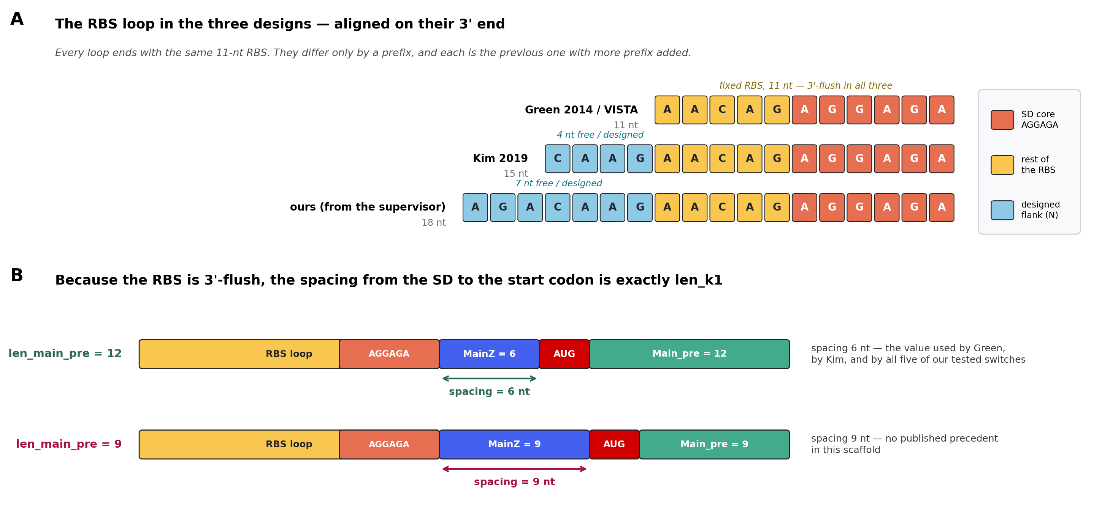
Figure 4. Top: the RBS loop in the three designs, aligned on their 3' ends. Bottom: because the RBS is 3'-flush, the Shine–Dalgarno-to-start-codon spacing is exactly len_k1.
design | loop | length | designed flank | fixed RBS
Green 2014 / VISTA | AACAGAGGAGA | 11 nt | — none | AACAGAGGAGA
Kim 2019 | CAAGAACAGAGGAGA | 15 nt | CAAG | AACAGAGGAGA
ours (from the supervisor) | AGACAAGAACAGAGGAGA | 18 nt | AGACAAG | AACAGAGGAGA

Our loop is Kim's loop with AGA added, and Kim's is Green's with CAAG added. There is no methodological disagreement between the three to resolve — only a choice of how much designed flank to put in front of a constant RBS.
First consequence: the RBS being 3'-flush is what fixes len_k1. Nothing separates the Shine–Dalgarno sequence from the start codon except k1 itself, so the spacing that governs translation initiation *is* len_k1. Measured directly:
construct | SD → AUG spacing
Green / VISTA fixed scaffold | 6 nt
Kim Sw-G5-G3n11 | 6 nt
our five tested switches (candidates 1–5) | 6 nt in all five
A0 with len_main_pre = 12 | 6 nt
A0 with len_main_pre = 9 | 9 nt — no precedent in this scaffold

This is the argument for splitting the 18-bp main stem as 12 + 6 rather than 9 + 9. The split is thermodynamically inert either way (§6.4), so nothing is paid for it — and 12 + 6 is the only split that reproduces the spacing used by both published designs and by every switch we have tested at the bench.
Second consequence: loops are not portable. We substituted each of the three loops into all five of our tested switches, changing nothing else, and folded the result:
loop substituted in | mean P(RBS entirely unpaired) | intended hairpin still formed?
Green, 11 nt | 0.77 | yes, in 5 of 5
Kim, 15 nt | 0.33 | no — in 0 of 5
ours, 18 nt | 0.68 | yes, in 5 of 5

Kim's loop does not merely score worse — dropped into our sequence context it refolds the whole switch into a different global structure, in every one of the five. A loop that is correct in one construct can be wrong in the next. Whatever loop is chosen, the intended fold has to be re-verified for every design (assertion 2, §8).
The one mild surprise, for you to weigh
Green's shorter 11-nt loop gives slightly better RBS accessibility than ours in four of the five tested switches (mean 0.77 vs 0.68). The margin is small and our 18-nt loop is the one with bench data behind it, so our recommendation is to keep the 18-nt loop unchanged — but you should know the shorter loop measures marginally better before signing that off. This is decision D12.

Third consequence: the pattern-prevention list needs a scope. Kim forbade aaaa, cccc, gggg, uuuu and the six-long IUPAC runs kkkkkk, mmmmmm, rrrrrr, ssssss, wwwwww, yyyyyy; our generator uses the identical list. But the RBS itself is AGGAGA — six purines — so it violates rrrrrr. The list must be applied to designed positions only, never to fixed domains, or the designer will refuse to place the ribosome binding site.
6.7 The inhibitory loop
Kim used two different methods for this loop in the same paper, and it matters which one we are copying.
Kim construct series | inhibitory loop | method
Sw-G5-G3n* (Kim's Figure 1) — the series this architecture is based on | CAAGAACUUAGACAA, 15 nt, fixed | carried over from an earlier Green-derived switch; not designed for this paper
Sw-T0-T3 (Kim's Figure 2) — a different construct | designed de novo | NUPACK, declared as domain a = N21 with the prevent list above

Two details of the de-novo route are easy to misread, so they are recorded here exactly as the supporting information gives them. First, N21 is not the loop: read against the structure string, those 21 free nucleotides span 3 nt of the hairpin's upper stem, the 12-nt loop, and 6 nt of the closing strand. Second, that hairpin has a 12-bp stem and a 12-nt loop, not the 19-bp stem and 15-nt loop of Kim's Figure 1 series — the two are different constructs.
Recommendation. Start from Kim's fixed 15-nt loop, which we verified carries no SD-like motif and no start codon, and check the intended fold for each design. Where it fails that check, design the loop de novo in NUPACK exactly as Kim did — free N nucleotides, the prevent list applied to designed positions only, and the intended structure as the design target. §6.6 shows this failure is not hypothetical: a fixed loop that suits one sequence context can break the next, and the secondary hairpin's stem is set by the gene pair and therefore changes with every design. This is decision D7.
7. How designs will be evaluated
7.1 Report the centroid, not only the MFE
For each of the four states we report the MFE structure and its free energy, the probability of the MFE structure, the centroid structure with its energy and its distance from the MFE, the ensemble free energy, and the ensemble diversity.
The reason is that P(MFE) collapses with length, and our constructs are long. Measured on a real two-hairpin switch, extended stepwise:
what is folded | length | P(MFE) | centroid distance from MFE
one hairpin alone | 70 nt | 0.44 | 0.9 bp
two-hairpin switch, no reporter | 129 nt | 0.023 | 6 bp
switch + linker + first 90 nt of GFP | 240 nt | 1.4 × 10⁻⁴ | 28 bp
full construct with GFP | 909 nt | 9.5 × 10⁻¹⁵ | 151 bp

At full length the MFE structure is one microstate in 10¹⁴ and describes essentially nothing. Any ranking that reads a single structure at that length is reading noise. The operative descriptions are the centroid and the base-pairing probability matrix; the MFE remains meaningful only for the isolated hairpin regions, where P(MFE) is still order 0.1–0.5.
The intended OFF structure is written directly from the element spans in Table 2, independently of any folding, and compared against both the MFE and the centroid. Both agreements are reported.
This is not a theoretical concern — the two descriptions already disagree on the only question we actually ask. Folding our five tested switches at three lengths and asking each structure whether the start codon is paired:
what is folded | P(MFE) | MFE and centroid agree on 'is the AUG paired?'
switch alone (95–107 nt) | 0.02 – 0.08 | 5 of 5
switch + 90 nt of GFP (185–197 nt) | 10⁻⁴ – 10⁻² | 5 of 5
full construct with GFP (854–866 nt) | ≈ 3 × 10⁻¹⁵ | 3 of 5

Where P(MFE) is order 10⁻² the two agree everywhere. Where it is order 10⁻¹⁵ they disagree about whether the gate is open in two of five constructs — and there is no basis in the numbers for preferring the MFE's answer. Which structure the ranking reads is decision D11, and we recommend the centroid together with the base-pairing probability matrix at full length, with the MFE reported but used only over the isolated hairpin region where it still means something.
7.2 Accessibility around the start codon
Recommendation: report the probability that a defined window around the start codon is entirely unpaired at once, not the average over its bases.
P_open(W) = Z( all of W unpaired ) / Z
dG_open(W) = - RT · ln P_open(W)
Why this rather than the usual metric. The common measure averages the unpaired probability across the window's bases. A ribosome does not sample bases independently — it needs its whole footprint free at the same moment. For a window whose bases are each 90 % unpaired, the averaged metric always reads 0.90, while the joint probability lies anywhere between 0.90 (if the bases open together) and far less (if they open independently). The two can rank designs differently, and only the joint probability corresponds to the physical requirement.
Windows, all anchored on the start codon and reported as a nested series:
- the AUG alone (3 nt);
- the RBS through the AUG — the Shine–Dalgarno spacing region;
- AUG through AUG + 3n, for n = 1 … 10 codons;
- the standard 30-nt ribosome footprint.
The rankable quantity is the difference between states: ΔΔG_open = dG_open(state 11) − dG_open(worst of 00, 01, 10). Reporting the whole nested series rather than one window shows how far the opening extends, which is what distinguishes a switch that merely exposes the AUG from one that clears the ribosome's path.
Implementation. ViennaRNA computes this directly: build a fold compound, apply hard constraints forcing the window unpaired, and take the free-energy difference between the constrained and unconstrained ensembles. One extra partition function per window.
7.3 Four-state energetics
The truth table is evaluated as a multi-strand equilibrium over the four states, reporting for each: the ensemble free energy, the base-pairing probability matrix, and the accessibility series of §7.2. The headline discrimination is
ddG_AND = [ dG_open(11) - dG_open(01) ] - [ dG_open(10) - dG_open(00) ]
which measures how much more trigger A opens the switch when trigger B is present than when it is absent. Length cancels in the difference, so this number needs no normalisation.
7.4 Trigger–trigger sequestration
Reported at a stated concentration (10 nM per transcript unless changed), as both the duplex free energy and the resulting bound fraction, alongside the longest complementary run. Per §5.1 this is a ranking input, not a pass/fail gate.
8. Validation the code must run
Each item below is an assertion that halts the run, not a line in a report.
# | assertion
1 | Every declared helix pairs antiparallel with zero mismatches (G·U wobbles allowed only where explicitly declared). This is the check that catches domain-order errors.
2 | The intended OFF dot-bracket, written from the element spans and independent of any folding, is diffed against both the MFE and the centroid.
3 | The cap sits at the 5' end of the finished construct, not stranded internally.
4 | (len_main_pre + len_LINKER) mod 3 = 0.
5 | No in-frame stop codon from the AUG through the end of the GFP CDS.
6 | No AUG between the RBS loop and the intended start codon that could initiate out of frame.
7 | The RBS appears exactly once; no second SD-like motif in the added 5' region.
8 | MainZ binds k1* strictly weaker than trigger A's k1 does, by at least ddG_pref. Same for SecondaryZ against k2.
9 | len_x ≥ 4. For len_x ≥ 8 the longest uninterrupted complementary run between the two triggers is ≤ 4 nt. At every len_x the measured duplex free energy and bound fraction between the two real trigger sequences are recorded, and the run cap is treated as a pre-filter, not as the acceptance test (§5.1).
10 | len_x + len_k2 = 18 and len_main_pre + len_k1 = 18.
11 | Trigger A's x and trigger B's Secondary_pre are reverse complements over the matched positions.
12 | Any design carried between stages is matched on its full identity (len_x, len_main_pre, len_k1, len_k2, ddG_pref, mismatch pattern), never on a partial key.
13 | The RBS is 3'-flush in the loop, and the SD→AUG spacing equals len_k1 and is reported for every design (§6.6).
14 | Any pattern-prevention list passed to a sequence designer is scoped to designed positions only. Applied to the whole strand it would reject the ribosome binding site itself (§6.6).
15 | Where the MFE and the centroid disagree on whether the start codon is paired, the design is flagged in the output rather than silently ranked (§7.1).

9. Open decisions
These are the decisions we need before implementation. D1, D2, D5, D8, D9 and D12 carry a recommendation we are ready to act on unless you disagree; D3, D4, D6, D7, D10 and D11 are genuine choices where we do not think the evidence settles it.
# | decision | our recommendation | why it matters
D1 | Stem length for both hairpins | 18 bp | Published values are 15 / 17 / 19. 18 sits inside the band and closes every other length in the design (§4.2).
D2 | Split of the main stem | 12 + 6 | The split is thermodynamically inert, but len_k1 *is* the Shine–Dalgarno-to-start spacing. Only 12 + 6 gives the 6 nt used by Green, by Kim and by all five of our tested switches (§6.6). Costs about 3 % of the search space to in-frame stops.
D3 | Trigger B total length | open — 50 nt as instructed, but 30–35 is the published precedent | 50 nt gives a 32-nt toehold where Kim used 13. Longer buys specificity but makes trigger B bind far harder than trigger A, which may unbalance the gate.
D4 | GFP's own leading ATG | open — we lean to deleting it | Green and Kim both keep it; our own switch generator deletes it. Measured: no thermodynamic difference, and no second start site either way (§6.5). A preference rather than a result, which is why we would rather you called it.
D5 | Overlap range and mismatch rule | |x| = 4 to 14; mismatches allowed at every length; longest complementary run ≤ 4 nt once |x| ≥ 8 | Corrects an earlier draft that capped the run at 7 — two 7-nt runs stitch together and reach 100 % sequestration. Mismatches below |x| = 8 buy nothing thermodynamically but are what lets the gene-pair search find anything at all (§5.1, §5.2).
D6 | Size and composition of the lab panel | open — 12 constructs proposed in §5.3 | Determines how many levels of |x| and ddG_pref we can afford to test.
D7 | Inhibitory loop — fixed or designed? | open — Kim's fixed 15-nt loop first, de-novo design where it fails the fold check | Kim used a fixed loop for the series we copy and de-novo NUPACK design for a different one. Loops are demonstrably not portable between sequence contexts (§6.6), and the secondary hairpin changes with every gene pair.
D8 | Include an a = 4 benchmark construct | yes | a = 0 is one step beyond Kim's tested range. A single a = 4 construct puts a known-working point in the panel.
D9 | Accessibility metric | joint (whole-window) unpaired probability | The averaged per-base metric does not correspond to what a ribosome requires (§7.2).
D10 | Input gene pairs for the reference study | open — awaiting your list | Not every gene pair admits a design: the two windows must be complementary over ≥ 4 nt. This blocks the search.
D11 | MFE or centroid when they disagree? | open — we lean to the centroid plus the pairing-probability matrix | At full construct length P(MFE) is about 3 × 10⁻¹⁵ and the two structures disagree about whether the start codon is paired in 2 of our 5 tested switches (§7.1). The counter-argument is comparability: the published tables and our own candidates report the MFE.
D12 | RBS loop sequence | keep the 18-nt loop AGACAAGAACAGAGGAGA | It is the loop our tested switches used, and it holds the intended fold in all five. Noted for the record: Green's shorter 11-nt loop measures marginally better on RBS accessibility, 0.77 against 0.68 (§6.6).

Table 4 — shaded rows are the six genuine choices.
Appendix A. Fixed sequences
name | sequence | notes
cap | GGG | 3 nt; transcription start, 5' end of the construct
RBS | AACAGAGGAGA | 11 nt, fixed. Identical in Green, in Kim and in our own generator. Sits flush against the 3' end of the RBS loop.
RBS loop | AGACAAGAACAGAGGAGA | 18 nt = designed flank AGACAAG + the fixed RBS. Equals Kim's 15-nt loop with AGA added, and Green's 11-nt loop with AGACAAG added (§6.6). See D12.
Secondary loop | CAAGAACUUAGACAA | 15 nt; the inhibitory-hairpin loop of Kim's Sw-G5-G3n* series (their Table S2-1). Verified to contain no SD-like motif and no start codon. See D7.
LINKER | AACCUGGCGGCAGCGCAAAAG | 21 nt = N L A A A Q K; no in-frame stop. Identical in Green and Kim, and contains no SD-like motif, so it creates no second start site (§6.5).
GFP CDS | ATGCGTAAAGGAGAAGAACTT… (759 nt) | 253 codons; divisible by 3; the only in-frame stops are the terminal TAA TAA. Begins with its own ATG — see D4.
prevent list | aaaa, cccc, gggg, uuuu, kkkkkk, mmmmmm, rrrrrr, ssssss, wwwwww, yyyyyy | Kim's pattern-prevention list, identical to the one in our own generator. Applies to designed positions only — the RBS itself violates rrrrrr (§6.6).

Appendix B. Sources and methods
- Kim et al., 2019, Modulating responses of toehold switches by an inhibitory hairpin — the two-hairpin architecture, the a / * trade-off, and the finding that small a produces a genuine AND gate.
- Robson & Green, 2026, Toehold-VISTA (Nucleic Acids Research) — the Series A / tsgen2 switch scaffold, the 21-nt linker, and the in-frame-stop filter.
- Geometry in Table 1 was measured, not quoted: each construct was rebuilt from the supplementary sequences and folded with ViennaRNA 2.7.2, default model, 37 °C. Kim's stem lengths were confirmed against the NUPACK design specification in their supporting information.
- Duplex energies and sequestration (Figure 3, §5.1) use ViennaRNA duplexfold at 37 °C, averaged over 400–500 random sequences per point, with both transcripts at 10 nM. Bound fraction is the solution of A + B ⇌ AB at equal totals.
- Bulge advantage (§6.4) and P(MFE) decay (§7.1) were computed with ViennaRNA fold and partition-function routines on the same constructs.
- Loop sequences were read from the primary sources, not inferred: Green's from the fixed 5' stem / loop / 3' stem string given in the Toehold-VISTA methods; Kim's from the switch sequences in their Supplementary Table S2, and their de-novo design specification from the DU+ script reproduced in their supporting information. Our own loop and prevent list were read from the lab's switch generator.
- Loop substitution, RBS and start-codon accessibility, the GFP internal-initiation scan, in-frame-stop rates, the mismatch placement study and the MFE-versus-centroid comparison were computed with ViennaRNA 2.7.2 at 37 °C, default model. Joint unpaired probabilities use a hard-constrained partition function; bound fractions solve A + B ⇌ AB with both strands at 10 nM.
- This document is generated by spec/build_spec.py. Edit that script and re-run rather than editing the .docx.

